mobibench源码阅读文档

In Mobibench, one can generate two types of workloads: file operations and database operations. Mobibench specifies spatial locality (random vs. sequential), I/O mode ( read vs. write), file size, I/O unit size, and synchronization mode. There exist five synchronization modes: buffered, synchronous, direct, mmap, and write()+fsync().

Mobibench generates three performance values: throughput, CPU utilization, and the number ofcontext switches. In file I/O test, units of throughput are “KB/s” for sequential operations and “IOPS”for random operations. Unit of throughput in SQLite operation is “transaction/ sec”. Utilization of CPU distinguishes ACTIVE, IDLE, and IO-WAIT to understand how the test utilizes the CPU. Mobibench also counts the number of context switches to measure the context switch overheads.

mobibench和mobigen在IO栈中的位置如图1所示

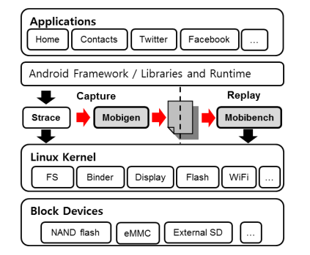

图1 mobibench和mobigen在IO栈中的位置

## Usage (shell version)

# mobibench [-p pathname] [-f file_size_Kb] [-r record_size_Kb] [-a access_mode] [-h]

[-y sync_mode] [-t thread_num] [-d db_mode] [-n db_transcations]

[-j SQLite_journalmode] [-s SQLite_syncmode] [-g replay_script] [-q]

* -p set path name (default=./mobibench)
* -f set file size in KBytes (default=1024)
* -r set record size in KBytes (default=4)
* -a set access mode (0=Write, 1=Random Write, 2=Read, 3=Random Read) (default=0)
* -y set sync mode (0=Normal, 1=O_SYNC, 2=fsync, 3=O_DIRECT, 4=Sync+direct, 5=mmap, 6=mmap+MS_ASYNC, 7=mmap+MS_SYNC 8=fdatasync) (default=0)
* -t set number of thread for test (default=1)
* -d enable DB test mode (0=insert, 1=update, 2=delete)
* -n set number of DB transaction (default=10)
* -j set SQLite journal mode (0=DELETE, 1=TRUNCATE, 2=PERSIST, 3=WAL, 4=MEMORY, 5=OFF) (default=1)
* -s set SQLite synchronous mode (0=OFF, 1=NORMAL, 2=FULL) (default=2)
* -g set replay script (output of MobiGen)
* -q do not display progress(%) message

# mobibench关键数据结构

## file_test_mode_t;

文件测试模式，写、随机写、读、随机读

typedef enum

{

MODE_WRITE,

MODE_RND_WRITE,

MODE_READ,

MODE_RND_READ,

} file_test_mode_t;

## file_sync_mode_t

文件同步模式

typedef enum

{

NORMAL,

OSYNC,

FSYNC,

ODIRECT,

SYDI,

MMAP,

MMAP_AS,

MMAP_S,

FDATASYNC,

} file_sync_mode_t;

## thread_status_t

线程的状态

typedef enum

{

NONE,

READY,

EXEC,

END,

ERROR,

} thread_status_t;

## struct script_entry

存放输入文件的信息，命令和命令的参数，命令实际执行过程中启动的线程数。

struct script_entry {

int thread_num;

long long time;

char* cmd;

char* args[3];

int arg_num;

};

## struct script_thread_time

线程时间

struct script_thread_time {

int thread_num;

int count;

int started;

int ended;

long long start;

long long end;

long long io_time;

int io_count;

int write_size;

int read_size;

};

## struct script_thread_info

线程信息

struct script_thread_info {

int thread_num;

int line_count;

int open_count;

};

## struct script_fd_conv

fd_conv暂时不知道具体意义，后续添加

struct script_fd_conv {

int* fd_org;

int* fd_new;

int index;

};

# mobibench关键函数流程

在mobibench分两种测试模式，若提供测试脚本则按照则是脚本测试，否则按照配置的参数进行测试。mobibench的整体调用图如下：

amin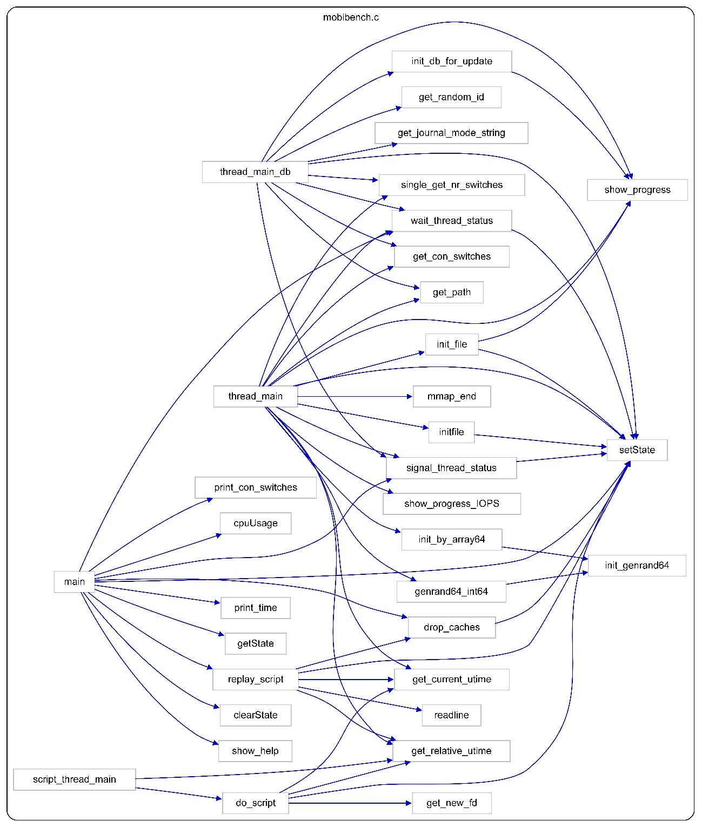

# 关键函数代码解析

mobibench在提供输入脚本时会对输入脚本的命令进行回放，若未提供输入脚本，则对按照配置参数进行回放，在提供脚本时参与回放的关键的函数有replay_script, script_thread_main, do_script；指定配置参数参与回放的关键函数有thread_main，thread_main_db

## replay_script函数

replay_script首先会对读取输入脚本信息，然后将输入脚本中命令和参数存放在gScriptEntry结构体中，分配线程内存，清空缓存，创建线程(pthread_create)，并且将script_thread_main作为线程入口函数，换句话说，创建线程的时候会调用script_thread_main。

创建线程：

while(1) {

time_current = get_relative_utime(time_start);

for(i = 0; i < script_thread_num; i++)

{

if(gScriptThreadTime[i].started == 0)

{

/* If the start time of a thread reached, create the thread. */

if(gScriptThreadTime[i].start <= (time_current+1000000)) /* 1sec margin */

{

thread_info[i].thread_num = gScriptThreadTime[i].thread_num;

thread_info[i].line_count = line_count;

thread_info[i].open_count = open_count;

ret = pthread_create((pthread_t *)&thread_id[i], NULL, (void*)script_thread_main, &thread_info[i]);//线程的入口函数

pthread_detach(thread_id[i]);

gScriptThreadTime[i].started = 1;

thread_start_cnt++;

}

}

}

if(thread_start_cnt >= script_thread_num) {

break;

}

}

## pthread_create函数

pthread_create函数是Linux与线程创建有关的线程函数

函数声明：

int pthread_create (pthread_t *tidp,const pthread_attr_t *attr,(void*)(*start_rtn)(void*), void *arg);

函数参数：

第一个参数为指向线程标识符的指针。

第二个参数用来设置线程属性。

第三个参数是线程运行函数的起始地址。

最后一个参数是运行函数的参数。

## script_thread_main

script_thread_main为启动线程的入口函数，统计线程的IO时间、写请求和读请求大小，当脚本命令的下发时间晚于mobibench创建线程时间时，线程会选择休眠。通过do_script函数执行线程的实际动作。

函数声明：

int script_thread_main(void* arg)

参数：

提供script_thread_info结构变量

gScriptThreadTime[thread_num].io_time = 0;

gScriptThreadTime[thread_num].write_size = 0;

gScriptThreadTime[thread_num].read_size = 0;

//printf("thread[%d] started at %lld, org %lld\n", thread_num, get_relative_utime(time_start), gScriptThreadTime[thread_num].start);

for(i = 0; i < thread_info->line_count; i++)

{

if(gScriptEntry[i].thread_num == thread_num)

{

long long time_diff = gScriptEntry[i].time - get_relative_utime(time_start);

if(time_diff > 1)

{

//printf("sleep %lld\n", time_diff);

usleep(time_diff-1);

}

//printf("%lld\n", get_relative_utime(time_start) - gScriptEntry[i].time);

io_time = do_script(&gScriptEntry[i], &gScriptThreadTime[thread_num]);

usleep(0);

if(io_time >= 0)

{

gScriptThreadTime[thread_num].io_time += io_time;

gScriptThreadTime[thread_num].io_count++;

//printf("thread[%d] %s\n", thread_num, gScriptEntry[i].cmd);

}

}

}

## do_script

函数声明：

int do_script(struct script_entry* se, struct script_thread_time* st)

下图是do_script的结构图，在do_script函数中处理输入脚本的命令有：open, close, write, pwrite, read, pread, fsync, fdatasync, access, stat, lstat, fstat, unlink。这些命令依次调用系统函数下发实际操作。

int fd_new = get_new_fd(atoi(se->args[0])); //获取新的 file descriptor

ret = write(fd_new, script_write_buf, atoi(se->args[1]));

int fd_new = get_new_fd(atoi(se->args[0])); //获取新的 file descriptor

ret = pwrite(fd_new, script_write_buf, atoi(se->args[2]), atoi(se->args[1]));

int fd_new = get_new_fd(atoi(se->args[0])); //获取新的 file descriptor

ret = read(fd_new, script_read_buf, atoi(se->args[1]));

int fd_new = get_new_fd(atoi(se->args[0])); //获取新的 file descriptor

ret = pread(fd_new, script_read_buf, atoi(se->args[2]), atoi(se->args[1]));

int fd_new = get_new_fd(atoi(se->args[0])); //获取新的 file descriptor

ret = fsync(fd_new);

int fd_new = get_new_fd(atoi(se->args[0])); //获取新的 file descriptor

ret = fstat64(fd_new, &stat_buf);

ret = access(replay_pathname, 0777);

ret = stat64(replay_pathname, &stat_buf);

ret = lstat64(replay_pathname, &stat_buf);

ret = unlink(replay_pathname);

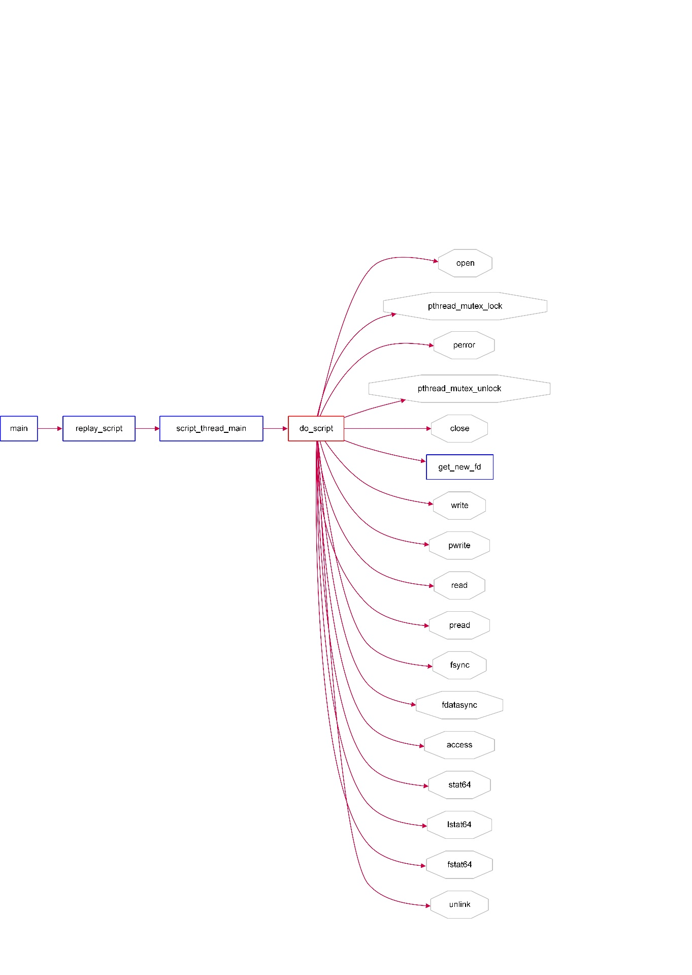

## pthread_mutex_lock和pthread_mutex_unlock

函数声明：

int pthread_mutex_lock(pthread_mutex_t *mutex);

当pthread_mutex_lock()返回时，该互斥锁已被锁定。线程调用该函数让互斥锁上锁，如果该互斥锁已被另一个线程锁定和拥有，则调用该线程将阻塞，直到该互斥锁变为可用为止。

函数声明：

int pthread_mutex_unlock(pthread_mutex_t *mutex);

pthread_mutex_unlock是可以解除锁定 mutex 所指向的互斥锁的函数。

mobibench在按照指定参数的下回放时，会判断是否使能SQlite数据库参与回放，这里存在两个与线程有关的回放函数thread_main，thread_main_db，这两个函数均作为创建线程函数的入口函数。

ret = pthread_create((pthread_t *)&thread_id[i], NULL, (void*)thread_main, &thread_info[i]);

ret = pthread_create((pthread_t *)&thread_id[i], NULL, (void*)thread_main_db, &thread_info[i]);